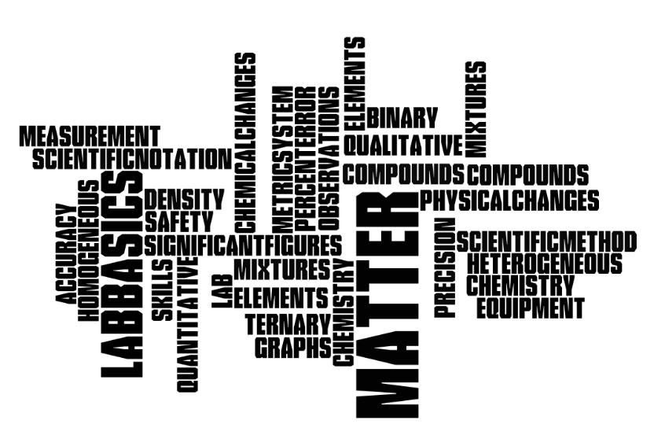

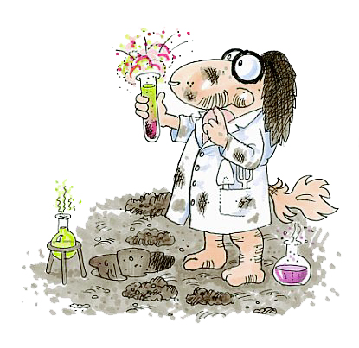

Homework Due : ___________________

Exam Dates:
Free Response ___________________ Multiple choice ___________________

Textbook chapters:
1~ Introduction to Chemistry; 2~ Matter & Change; 3~ Scientific Method

Study Guide Outline for Topic # 1
-Introduction
Chemistry: The study of matter and the changes that matter undergoes

Investigation of chemistry:
Using the scientific method (laboratory experiments)
Theory:  explanation supported by many  experiments and answers 'why' | Law:  a relationship in nature supported by many  experiments

-Science and lab activities:

Observations:
Quantitative: An observation that describes using numbers, measurements or amount.

Measurements:

- Metric System (Table C)
- Scientific Notation
- Significant figures used when reporting scientific data because they give the reader an idea of how well you could actually measure data. Significant figures are dependent on the equipment markings you are using.
- Include units for measurements! (Table D)
Remember the rules:
  - ALL non-zero numbers (1,2,3,4,5,6,7,8,9) are ALWAYS significant.
  - Leading Zeros within a number are NEVER significant. Both .023 and 0.0019 contain only 2 significant figures.
  - Trailing Zeros WITHOUT a decimal point are NOT significant. Thus, 470,000 has only two significant figures. BUT 270. and 1.90 each have 3 significant figures.
  - Squished zeros between significant numbers are ALWAYS significant. Both 1001 and 3.020 each have 2 significant figures.
Addition and Subtraction with Significant Figures
- When measurements are added or subtracted, the answer can contain no more decimal places than the least accurate measurement.
Multiplication and Division with Significant Figures
- When measurements are multiplied or divided, the answer can contain no more significant figures than the least accurate measurement.
- Density (Table T)
- Accuracy (percent error - Table T) versus Precision

Qualitative: An observation non numerical, description of shape, color, odor or temperature.
- States of matter
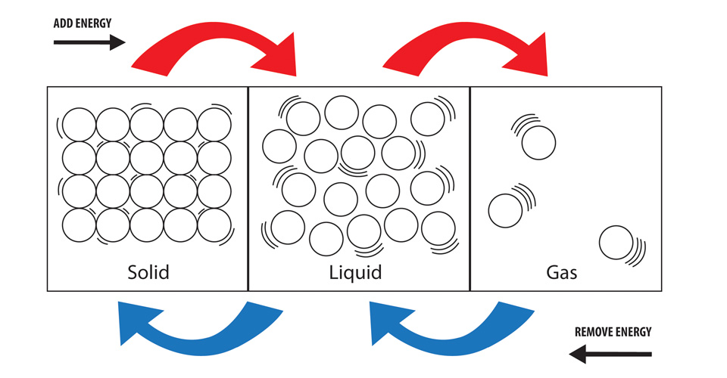

Identify :
Physical versus Chemical Properties

Physical versus Chemical Changes

Classification of Matter:
Matter
takes up space and has mass

Mixture
variable composition
Pure Substance
definite composition; homogeneous

Element
made up of atoms, cannot be further separated by physical or chemical means
Compound
chemical combination of two or more atoms
Solution
particles atoms, ions, or compounds, won’t scatter light

Heterogeneous Mixture
not uniform throughout
Homogeneous Mixture
uniform throughout but proportions not set
Homogeneous Mixture
uniform throughout but proportions not set

VOCABULARY
Chemistry Elements
Scientific method Compounds (binary vs. ternary)
Qualitative Mixtures (homogeneous vs. heterogeneous)
Quantitative States of Matter (solid, liquid, gas)
Density physical vs. chemical changes
Accuracy physical vs. chemical properties
Precision

Matter and Lab Basics Homework
Basics of Chemistry
TEXT Pages 28-30
38. Firefighters need to know what chemicals to use to put out the fire and how fire spreads. Also need to know if there are chemicals involved in the fire. A reporter would need to know chemistry as background info during interviews.
Pages 28-30
50. to share knowledge across disciplines and resources between industry and academia in order to make
cutting edge inventions, discoveries and changes.
Pages 28-30
81. knowledge of chemistry can help prioritize environmental issues.
Pages 55-58
95. to have a better understanding of changes occurring in the park and help assess if changes are normal
or harmful.

Pearson SuccessNet Online
Follow the slides and Complete online questions Chapter 1 → level activities → concepts in action:
What would happen in a world without chemistry?
Chemistry developed: Plastic foams, dyes, metal alloys, gasoline, medicines
Pure Chemistry: the facts and theories of chemistry in their purely scientific relations, without necessary reference to their practical applications;chemical reactions & composition
Applied Chemistry: the application of the theories and principles of chemistry to practical purposes;
strength of alloys, medicines

Pearson SuccessNet Online
Watch the video Chapter 1 → level activities → What good chemistry can do?

Measurements
TEXT Pages 28-30
55.
72 beats = x beats 60 minutes x 24 hours = 1440 minutes
1 minute 60 minutes
72 beats = x beats
4320 beats/hour 1 minute 1440 minutes

103, 680 beats/day

Pages 95-98
57. b. 4 c. 1 f. 3
58. a. 98.5 b. .000763 f. 1760

59.
A E
43g
32.4g

70. CO₂ would sink (heavier than air)
Ne & H₂ would rise (lighter than air)

83. .69- .789 g/cm³
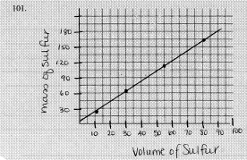
101.

Density = mass
Volume 19.3g/mL = 34.5g 1.79mL
x
107.

Page 99

1. B
2. C
3. D
4. D

8. b c a

Pearson SuccessNet Online
Watch The Video Chapter 3 → Level Activities → Being precisely Accurate.

Pearson SuccessNet Online
Follow the slides and Complete online questions Chapter 3 → level activities →
concepts in action: SI Units! Exactly!

Pearson SuccessNet Online
Using the Kinetic art Activity answer online questions Chapter 3 →
3.1 Kinetic Art Precision in measurement

Matter
Pages 28-30
34. air has mass and occupies space
Pages 28-30

73. diagram C 80% N₂ : 20% O₂ → 4:1 ratio
Pages 55-58
41. odor, melting point/ boiling point

Pages 55-58
45. solid particles → close /tightly packed
gas particles → far/ spread apart
46.
- Chlorine → condenses
- Mercury → freeze
- Bromine → freeze
- Water → freeze
Pages 55-58
48. homogeneous – uniform/ evenly distributed composition
heterogeneous – non uniform composition/ layers

50.

A. heterogeneous
B. homogeneous
C. depends on mixture
D. homogeneous
E. heterogeneous
F. homogeneous
G. heterogeneous
H. homogeneous

51. separate liquids by boiling points, heat→ vaporize→ condense
54.
- Nitrogen, hydrogen
- Potassium, oxygen
- Carbon, hydrogen, oxygen
- Calcium, sulfur
60.
- physical
- chemical (color change)
- chemical (produce gas)
- physical

63. ethanol
64. neon
65. sulfur
66. sulfur

72.

- heterogeneous mixture
- compound
- homogeneous mixture
- heterogeneous mixture

Pages 55-58
73.

- physical
- physical
- physical
- physical
- chemical

81. add water to dissolved sugar, separate sand and charcoal from sugar water by filtration.
Charcoal can be separated by size & color.
95. to have a better understanding of these changes occurring in the park. Will help them assess if
changes are normal or harmful

Page 59
5. B
6. D
7. A
8. C
9. B

